Setup minikube at your local and explore creating namespaces

Setting up minikube

Connect to an ec2 instance

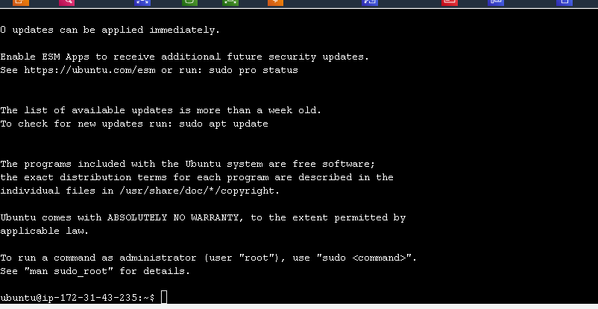

Installing docker

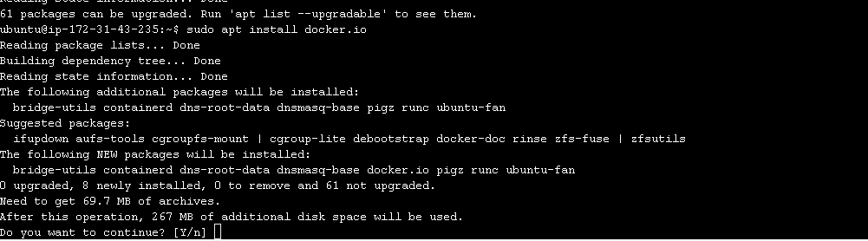

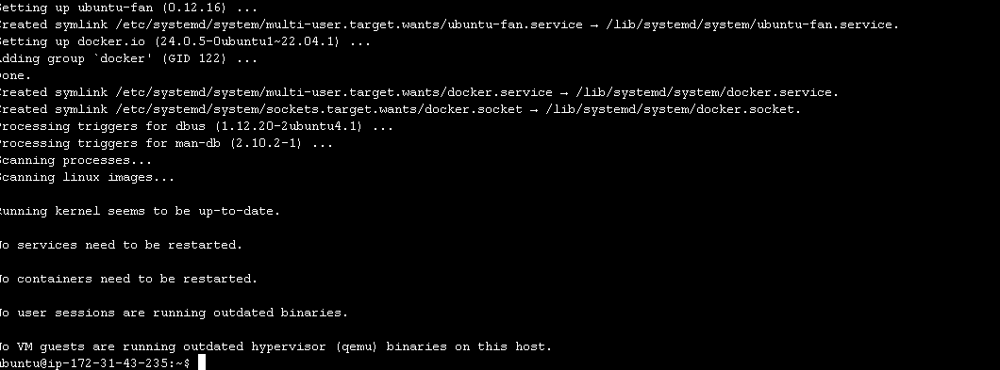

**Install Kubectl**

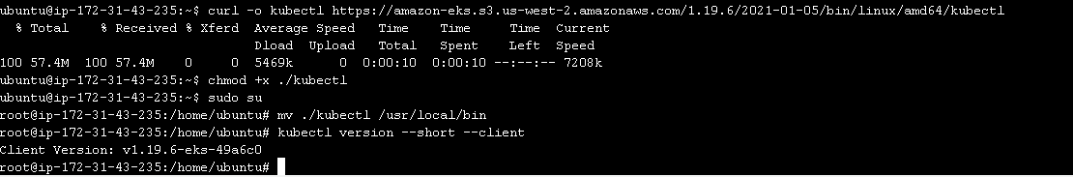

**Installing minikube**

